There are many studies have been published on the topic of discriminate Arabic dialect, we can divide our reading in these studies to two main approaches:

1. Researches that mainly concerns about identification between similar languages that are not Arabic.

Many papers was published on this context, below is a short summary for each one of them.

* One of good readings in this area was published by AlinaMariaCiobanu, SergiuNisioi and LiviuP.Dinu (2016)[1], they worked on dataset of 20,000 sentence in each language or variety (18,000 training + 2,000 development).
* Dfg
* Dfgf
* Dfg
* ksjngosk

1. Researches that concerns about identification between Arabic dialects.

We can this section to two main branches:

* Researches that come to solve same problem that we are working on.
* One of the best and recent papers in this context is Arabic Dialect Identification in Speech Transcripts for (Shervin Malmasi, Marcos Zampieri)[2].

This paper won the first place in the DSL2016 competition, with accuracy of 51%.

They used 7 different feature extraction methods to get the feature vectors, the methods was 1-6 character n-gram and word uni-gram, SVM model was built from each of these feature extraction techniques.

Moreover, to predict any new instance, they use 3 different techniques:

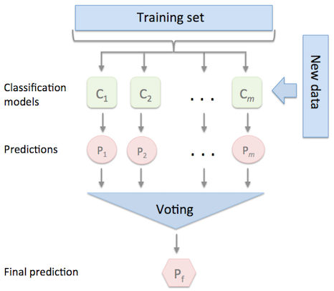

Figure 2.1: idea of voting between classifiers[3]

1. System #1: Pure voting (majority): in this method, each classifier will predict a single label, then the label with highest number of votes wins, other wise, the output will be selected randomly, this system made an accuracy of 49.16%.

2. System #2: Median probability ensemble: in this method, there is a probability assign to each label by each and every classifier, then we can find the median probability for each class, finally, label with largest median will wins, this system made an accuracy of 49.29%.

3. System #3: Mean probability ensemble: in this method, the same idea of last approach applied, the only difference is that mean probability deals with average probability instead of median probability, this system made an accuracy of 51.17%.

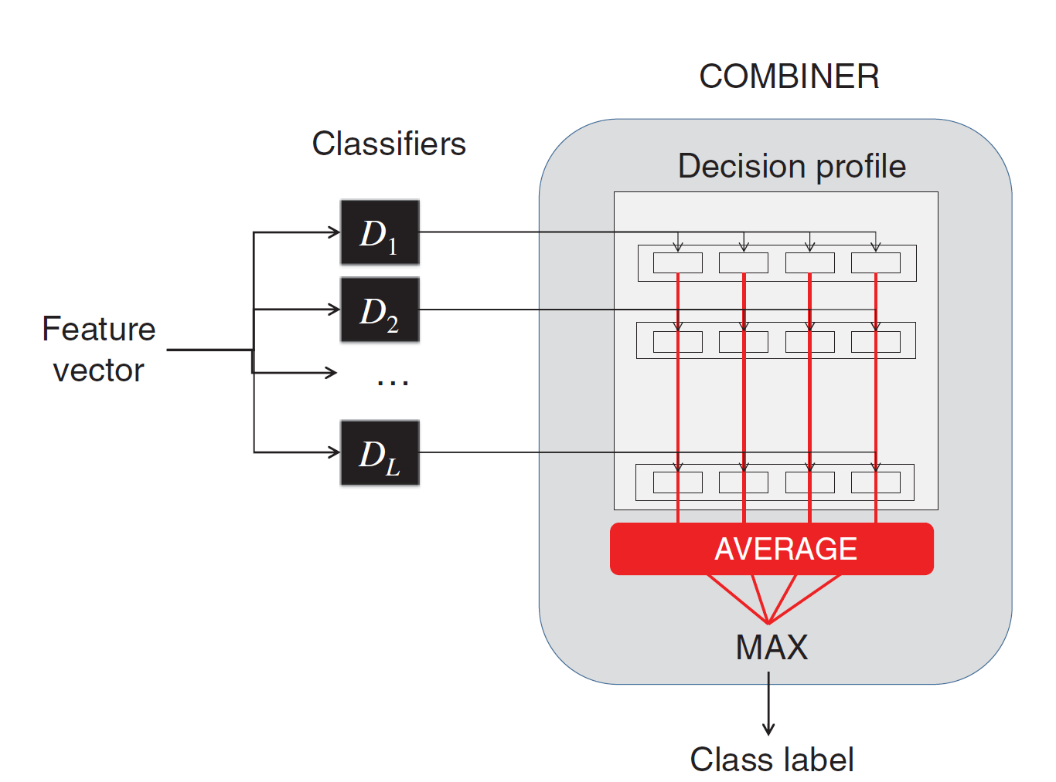

Figure2.2: An example of how mean probability ensemble works (for 4 label classification problem), each class take a probability from each classifier and then find the max from all averages.[4]

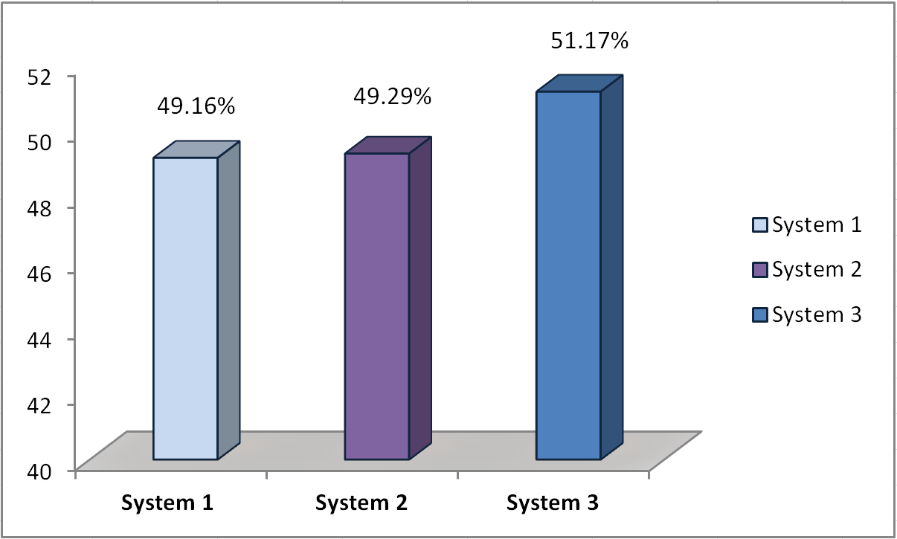

Figure 2.2:( Malmasi and Zampieri) Systems accuracies

* Researches that come so solve any Arabic dialects identification problem.

**[1:]** [**http://web.science.mq.edu.au/~smalmasi/vardial3/pdf/VarDial330.pdf**](http://web.science.mq.edu.au/~smalmasi/vardial3/pdf/VarDial330.pdf)

**[2]:** [**https://github.com/AhmadDarKhalil/project/blob/master/papers/Firtst.pdf**](https://github.com/AhmadDarKhalil/project/blob/master/papers/Firtst.pdf)

**[3]:** [**http://rasbt.github.io/mlxtend/user_guide/classifier/EnsembleVoteClassifier/**](http://rasbt.github.io/mlxtend/user_guide/classifier/EnsembleVoteClassifier/)

**[4]:**[**https://github.com/AhmadDarKhalil/project/blob/master/papers/malmasi2015Votin g.pdf**](https://github.com/AhmadDarKhalil/project/blob/master/papers/malmasi2015Votin%20g.pdf)